# SMART FASHION

## Before you collaborate

A little bit of preparation goes a long way with this session. Here’s what you need to do to get going.

**10 minutes**

### Define your problem1statement

Unavailability of chatbots that are interactive enough to navigate the user to do whatever they want.The amount of toil a user has to go through to look for a product they desire for. Need for a more User-friendly Interface.

The main aim of the project is to develop a smart chat-bot that is able to understand the needs of the user and recommend products of desire.

**2**

## Brainstorm

Write down any ideas that come to mind that address your proble

m statement.

**TIP**

You can select a sticky note and hit the pencil [switch to sketch] icon to start drawing!

**10 minutes**

**3**

## Group ideas

Take turns sharing your ideas while clustering similar or related notes as you go. In the last 10 minutes, give each cluster a sentence-like label. If a cluster is bigger than six sticky notes, try and see if you and break it up into smaller sub-groups.

**20 minutes**

**4**

## Prioritize

Your team should all be on the same page about what's important moving forward. Place your ideas on this grid to determine which ideas are important and which are feasible.

**20 minutes**

## After you collaborate

You can export the mural as an image or pdf to share with members of your company who might find it helpful.

TAMIL SELVAN R

**Quick add-ons**

# RECOMMENDATION

**Person 3 Person 4**

**Person 7 Person 8**

**PROBLEM**

**How might we [your problem statement]?**

**A Team gathering**

Define who should participate in the session and send an

invite. Share relevant information or pre-work ahead.

ARUN VIGNESH K

User

MOSAI I

1. **Share the mural**

**Share a view link** to the mural with stakeholders to keep them in the loop about the outcomes of the session.

User Friendly Web application

# Fashion applications have seen tremendous growth and are now one of the most used programs in the e-commerce field. The needs of people are continuously evolving, creating room for innovation among the

applications. Having an AI program that understands the

1. **Set the goal**

Think about the problem you'll be focusing on solving in the brainstorming session.

1. **Learn how to use the facilitation tools**

Use the Facilitation Superpowers to run a happy and productive session.

[**Open article**](https://support.mural.co/en/articles/2113740-facilitation-superpowers)

## Key rules of brainstorming

Instant product results based on preferences

Reduce user navigation

To run an smooth and productive session

Friendly Web application

Recommend required products

**MATHESH SUDHARSAN S**

Offers/Discount

Identify User preferences

smart chat- bot

Reduce user navigation

High performance

Interactive web application

**MOSAI I**

High resolution images for each product

Product recommendation

Handle secure payments

Well defined product description and its available categories

Well defined product description and its available categories

Handle secure payments

## Group 1

Integration of intelligent chat-bot

Offers/Discount

User Friendly Web application

Instant product results based on preferences

smart chat- bot

Reduce user navigation

## Group 2

High resolution images for each product

**TIP**

Add customizable tags to sticky notes to make it easier to find, browse, organize, and categorize important ideas as themes within your mural.

various preferences to be shown

**B Export the mural**

Export a copy of the mural as a PNG or PDF to attach to emails, include in slides, or save in your drive.

## Keep moving forward

**Strategy blueprint**

Define the components of a new idea or strategy.

[**Open the template**](https://app.mural.co/template/e95f612a-f72a-4772-bc48-545aaa04e0c9/984865a6-0a96-4472-a48d-47639307b3ca)

**Customer experience journey map**

Understand customer needs, motivations, and obstacles for an experience.

# algorithm of a specific application can be of great aid. We are implementing

Stay in topic. Defer judgment.

Encourage wild ideas. Listen to others.

Instant product results based on preferences

Secure Authentication

Integration of intelligent chat-bot

various preferences to be shown

High resolution images for each product

## Importance

If each of these

[**Open the template**](https://app.mural.co/template/b7114010-3a67-4d63-a51d-6f2cedc9633f/c1b465ab-57af-4624-8faf-ebb312edc0eb)

**Strengths, weaknesses, opportunities & threats**

Identify strengths, weaknesses, opportunities,

# such a chat bot, which is fed with the knowledge of the application’s algorithm and helps the user completely from finding their needs to processing the payment and initiating delivery.

Go for volume. If possible, be visual.

tasks could get

done without any difficulty or cost, which would have the most positive impact?

Handle secure payments

**TIP**

Participants can use their cursors to point at where sticky notes should go on the grid. The facilitator can confirm the spot by using the laser pointer holding the **H key** on the keyboard.

and threats (SWOT) to develop a plan.

[**Open the template**](https://app.mural.co/template/6a062671-89ee-4b76-9409-2603d8b098be/ca270343-1d54-4952-9d8c-fbc303ffd0f2)

Well defined product description and its available categories

|  |  |
| --- | --- |
|  |  |
|  |  |

[**Share template feedback**](https://muralco.typeform.com/to/CiqaHVat?typeform-source=app.mural.co)

Offers/Discount

[**Share template feedback**](https://muralco.typeform.com/to/CiqaHVat?typeform-source=app.mural.co)

## Feasibility

Regardless of their importance, which tasks are more feasible than others? (Cost, time, effort, complexity, etc.)

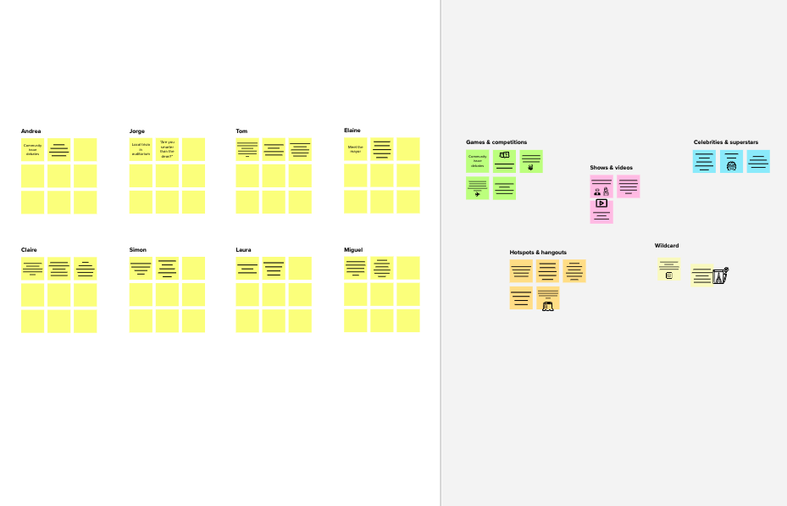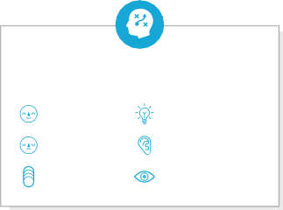

**Template**

### Need some inspiration?

See a finished version of this template to kickstart your work.

[**Open example**](https://app.mural.co/template/e5a93b7b-49f2-48c9-afd7-a635d860eba6/93f1b98d-b2d2-4695-8e85-7e9c0d2fd9b9)